Chapter 1:
Introduction and Overview

Objectives

After completing this section, you will be able to:

- Understand the training schedule and Course
Objectives
- Improve and Optimize your Maintenance System
- Explain the Benefits of TME
- Provide an Overview of the TME Modules
- Log On / Log Off
- Have a working knowledge of the common tasks and functions used in TME

Contents
Introduction 9
Standard Agenda 9
Course Objectives 10
TME Overview 11
TME: 11
Benefits of TME 12
TME Modules – An Overview 14
Terms Used In TME 17
Before Starting TME 18
Pop-Up Blocker 18
Turning Off the Pop-Up Blocker 18
Starting TME 22
How to Login 22
I Forgot My Password 23
Add This Page to My Favorites 23
How to Logout 24
Common Tasks 25
Taskbar 25
Viewer Toolbar 28
Data Collection 31
Grid Control Selection and Configuration 35
Details Screen Toolbar/Taskbar 36
Selecting a Locale 39
Item LookUp Screens 39
User Settings 40
Sorting by Column within a Viewer 40
Editing Drop-Down Lists 41
Table of Figures
Figure 1 Example of Pop-Up Blocker Setting 18
Figure 2 Alternate Example of Pop-Up Blocker Setting 19
Figure 3 Internet Options - Privacy Screen 19
Figure 4 Pop-Up Blocker Settings Screen 20
Figure 5 Compatibility View Settings for IE10 or Higher 21
Figure 6 Selection for Compatibility View 21
Figure 7 TME Log In Screen 22
Figure 8 TME "I Forgot My Password" screen 23
Figure 9 Internet Explorer Add a Favorite Screen 23
Figure 10 TME Session Has Ended Screen 24
Figure 11 TME Taskbar 25
Figure 12 TME Configure Workspace Screen 26
Figure 13 Default Page of Online Help Screen 27
Figure 14 Main Screen Toolbar 28
Figure 15 Viewer Toolbar 28
Figure 16 Viewer Search Control 29
Figure 17 Search Control Set with View 30
Figure 19 Asset Multi-Edit Feature 30
Figure 18 Records per Page Drop Down 30
Figure 20 Multi-Edit Properties Screen 31
Figure 21 Collection Screen for an Asset 31
Figure 22 Example of Numbers and Formula Variable Group 32
Figure 23 SPC Data Collection Screen and Xbar Chart 33
Figure 24 Data Viewed in Grid 33
Figure 25 Point Detail Screen 34
Figure 26 Example of Run Rules Setup (See Chapter 10 Settings for More Detail) 34
Figure 29 Columns Link for Grid 36
Figure 27 Grid Control Detail Screen 35
Figure 28 Permissions Link for Grid 35
Figure 30 Column Selection for Grid 36
Figure 32 Details Screen Toolbar/Taskbar 37
Figure 31 Grid Selection 36
Figure 33 Properties Screen of a Record 38
Figure 34 Select Locale Screen 39
Figure 35 Field Set to LookUp Screen 39
Figure 36 Item LookUp Screen 40
Figure 37 Drop Down List Editing Icons 41

Introduction

Welcome to Traceability Made Easy™ (referred to as TME) training. The knowledge gained during this course will help you perform all the features of TME. After the training, you will have an overall knowledge of the system and its effectiveness and an understanding of the capabilities of this system and exactly how it can help you minimize your workload.

Standard Agenda

Day 1-Morning
- TME Overview
- System Set Up and Settings
- Driver’s Seat – Messages and Dashboard: Operations, Asset Scheduling, Time Clock
- Contacts and Documents

Day 1-Afternoon
- Asset Management
- Check In/Out
- Inventory

Day 2-Morning
- Work Tracking – Work Orders, Scheduled Work, and Projects
- Purchasing
- SPC and Production

Day 2-Afternoon
- Reports

Day 3 (MES/WIP Only)
- Work in Progress (WIP) Set Up

Day 4 (MES/WIP Only)
- Work in Progress (WIP) Processing

Day 5
- End-User Training

Course Objectives

After completing this course, you will be able to:

- Have Insight on how TME works and how it will help you do your job more successfully
- Explain the benefits of TME
- Understand the purpose and function of each Module

- Have knowledge of how to best set up and manage the System based on your corporate policies and reporting needs
    - Set up Users / Access Groups / Email Groups and Permissions in the system
    - Enter the prerequisites to adding Assets
    - Set up and manage Inventory Items used to complete Work Orders and build product
    - Know how to use the Time Clock and Projects Sub-Modules for work outside the scope of Maintenance
    - Manage the Requisition and Purchase Orders process

- Create, process and complete maintenance Work Orders using the Operations Control and Work Tracking Module
- Log change(s) within the Major and Minor Status of an Asset
- Create a Non-Equipment Related Maintenance Request (NERMR)
- Send an Equipment Related Maintenance Request
- Set up Scheduled Work Orders
- Use the Real Time Status and Asset Downtime tools
- Close a Work Order—consume inventory, log hours and enter comments
- Reserve an Asset for repair/maintenance through the Reservation Calendar

- Communicate quickly and automatically to the appropriate stakeholders and provide extensive information using Messages, Documents and Contacts Modules as well as the Runtime Engine
- View / Send / Delete messages through Driver’s Seat
- Manage Contacts—individuals and companies
- Maintain an online filing system for documentation, invoices, safety instructions, maintenance procedures, etc.
- Monitor how the Runtime Engine automatically generates emails on Work Orders and SEMI E-10 Reports

- Understand how accurate Equipment Utilization reporting along with proactive Maintenance Management provides you with the ability to analyze and positively affect Overall Equipment Effectiveness (OEE)
- Set up Assets with detailed Categories / SubCategories with Modules, Failures and Corrective Actions
- Set up and collect data for statistical analysis and OEE calculations
- Be consistent and accurate when updating Equipment Status and handling/completing Work Orders
- Build / Edit / Send Reports to enable oversight of Assets, Personnel, and time frames

- Track Work in Process (WIP) to optimize production management
- Set up work flows using Processes, Operations and Steps that streamline Operators’ input and work processing
- Use Bills of Material (BOMs) to control material consumption
- Set up and collect data for statistical analysis and control maximization
- Control availability of equipment utilizing the tracking of past due Work Orders—repairs or preventive maintenance/qualifications/calibrations
- Limit Operators ability to process work based on the maintenance of up-to-date certifications
- Collect genealogy and reverse genealogy information on Product/Material using Batch Numbers and Serialization
- Able to report on Product history from start to finish, each and every step, including Sign Offs by Operators, Engineers, Production Managers, etc.

TME Overview

This overview provides a description of TME and all of its features.

TME:
- Provides comprehensive information on asset productivity and performance for equipment maintenance, facilities management, and product processing.

- Supports maintenance needs by tracking and reporting on equipment, supply usage, and maintenance contractors.

- Enables genealogy of Inventory Items built into Product via WIP or utilized within a Work Order for complete tracking of spare parts, materials, supplies or product.

- Provides a complete set of tools for the maintenance technician, operator, management level reporting and administration using a standard web browser.

- Enables management to make key decisions concerning available assets and current inventory using real-time reporting.

- Makes it easy to visualize your entire maintenance program with a comprehensive web-based tool set.

- Allows Users to better utilize their time on assigned tasks with tools centered on the User’s role in maintenance such as inventory tasks, work tracking, scheduling of work requests and completion notification.

Benefits of TME



1. TME provides objective data on equipment operational utilization, uptime, plant efficiency and outsourced maintenance activities. Manage and utilize all facilities resources, assets, equipment, contractors, and repair and maintenance staff with a single application.

2. TME provides equipment performance statistics based on scheduled production cycles. It helps improve equipment utilization by setting performance standards that increase equipment uptime consistently over its life cycle. Estimate production capacity and forecast availability more effectively by looking at past trends and equipment utilization for the entire facility. TME’s database provides historical performance of the entire facility to help support increased demand.



3. TME provides detailed data on Equipment Reliability, Availability, Maintainability (RAM) and utilization. Manage production assets by monitoring equipment efficiency and reviewing maintenance records to plan production schedules and maintenance intervals.

What kind of data would you like TME to provide?

4. TME Work Tracking provides the ability to create new work orders, assign them to personnel and track the process of the work order through completion. Equipment repairs or maintenance requests are tracked automatically to provide detailed reporting and work order history. Since the work-flow is all digital nothing gets lost or overlooked, and everything is updated immediately. The system even notifies personnel of past due work orders and emails them when a work order is completed.

What do you expect TME to do for you (WIIFM)?

TME Modules – An Overview
TME provides a unique set of features and functions to allow the Users to better track and report Equipment RAM (reliability, availability, maintainability). The modules are then broken into sub-modules to allow the User to perform detailed transactions.

To see a sitemap, please see Appendix 1 – TME Sitemap.

Driver’s Seat
- Dashboard – Allows Users to reserve assets such as production equipment for scheduled maintenance, repair or overhaul. It also contains a control designed for the employees who will be running the equipment. This is where Users can retrieve and update equipment status information. The Dashboard also contains a control that allows Users to track time spent on tasks other than maintenance
- Messages – Built in messaging system where a User can receive and send messages to existing TME Users (messages contained within TME, not interfaced with email).
- Report Browser – Provides access to the Master Reports included with TME or any of the customized reports built by TME Users.

Work Tracking
Users who will be using this module are the employees who are responsible for creating and/or completing Work Orders for equipment and/or managing Scheduled Work.

- Work Order – Provides tools to create and manage work orders
- Scheduled Work – Creates schedules for your Preventive
Maintenance
- Real Time Status/Asset Downtime List – Displays a graphic presentation
of the status of all your active equipment
- Calendar – A calendar of work orders
- Projects – Logging system for time and comments by Users working on tasks other then work orders
- Processes – For setting up Work Order templates built out of Operations
- Operations – Operations set up the Steps that comprise Work Orders
Asset Management
The Asset Management module provides a simple way to add Assets to a database that can be tracked in Work Orders, used to setup preventative maintenance schedules and provide equipment status.

- Assets – Add, edit, and view Assets as well as change the status of an
existing asset
- Reservation Approval – Viewer of Asset Reservations needing approval by a User with the appropriate authority
- Reconciliation – Allows Users to conduct an inventory of Assets and update locations accordingly. The database keeps a record of the locations for easy reporting on location history.

Check In/Out
The Check In/Out module allows for the tracking of assets that have been assigned to specific users.

Inventory
This module allows you to view, add and manage important information about your Inventory Items. You are able to view detailed inventory information such as Suppliers, Store locales, and Transaction Logs for each Inventory Item.

- Items – Add, edit, and view Inventory Items, set up Kits (aka Product)
- Quantities – Viewer to show what inventory is currently in the logged-in User’s possession or at any selected Locale; Users can conduct certain transactions directly from this screen.
- Receiving – Ability to receive inventory into the system at a specific locale
- BOM – Set up Bills of Material to attach to Assets, Work Orders, Scheduled Work, and Product
- Actions – Perform numerous transactions against inventory items including Consume, Scrap, Build Kits, Adjust, et al.

Purchasing
In this module Users are able to create, edit, and print Requisitions and Purchase Orders (POs).

- Requisitions -- Users request the ordering of tracked Inventory Items as well as non-tracked parts
- Purchase Orders – Users order the Items from suppliers and vendors

Documents
The Document module allows the User to view equipment manuals, operational procedures, warranty documents, training manuals and emergency procedures.
This makes it easier to access the most relevant information about the equipment. Documents are arranged by Cabinets, Drawers and Folders.

Contacts
The Contacts module provides a convenient way to organize all your contacts such as maintenance contractors, suppliers and technical support numbers; as well as TME Users and Groups (Access Groups and Email Groups).

- Companies – Provides an organized way of managing important details
about your vendors, suppliers, clients, etc.
- Departments – Set up the drop-down list of Departments
- Contacts – A list of contacts and TME Users that may or may not belong to one of the companies listed in the Companies sub-module
- Groups – Set up system permissions and email groups

Production
This is the module that will help Users collect production data and calculate Overall Equipment Effectiveness (OEE).

- Data Collection – Enter production numbers for an asset used in
manufacturing
- Product Capacity – Add or edit product capacity

Reports
In this module, Users are able to create reports, set up schedules for reports to run automatically and designate employees who are supposed to receive the reports.

- Report Menu – Displays only the reports that were set up to include you as
one of the Assigned Users
- Report Brower – Builds customized reports from a pool of easy-to-
use Report Sources
- Subscriptions – Provides the capability to generate reports and email
them on a scheduled basis to Users (can also store reports directly onto
server)

Work In Process (WIP)
This is the module that will help Users track and process Work In Process (WIP) work orders to take raw material and produce a final product.

- Work Orders – Provides tool for managing and processing WIP Work Orders
- Processes – For setting up Work Order templates built out of Operations
- Operations – Operations set up the Steps that comprise Work Orders
- Recipes – Set up the recipes with attached documentation used within WIP
- BOM LookUps – provides the ability to create cross references of Bills of Material to Products
- Recipe LookUps – provides the ability to create cross references of Recipes to Assets started in WIP
- Tool LookUps – provides the ability to create cross references of Tools to Assets started in WIP
Settings
This is the Administration module.

- Rate Codes –Create, edit and delete rate codes; specifies default rate code
- Locales – Create, edit, and delete locales used throughout the system
- Print – Set up the labels and forms used to print items with Asset Management, Inventory, Work Tracking, Users, and Purchasing
- Variable Groups – Set up the variables and group them for set up as Attribute (single instance data collection) fields for Assets, Inventory, Work Tracking, Requisitions, Purchase Orders, Locales and Production as well as for Data Collection (multi-instance) for Assets, Inventory, and Work Tracking
- Data Collection – Set up of Data Collections for selection against objects such as Assets, Inventory Items and Work Orders.
- Notification – customize email and text notifications that are generated throughout the system

The Options screen accessed via Tools on the Taskbar provides additional setup options for the Administrator.

Terms Used In TME
Before you start with the training, here are some
terms often used by TME.

- User = Employee
- Asset = Equipment
- Operator = Person who uses the equipment/process WIP Work Orders
- Maintenance Personnel = Person who is in-charge of fixing the equipment
- Notification = Sending of E-mail to inform employees
- Work Order (Maintenance) = Work that needs to be done for maintenance purposes
- WIP Work Order (Work In Process) = Work that needs to be done for making product from raw material
- Inventory = Consumables (Supplies, Materials) and/or Product

Before Starting TME

Pop-Up Blocker

TME is designed as a web application. A number of the links that exist within the system that when clicked will open new windows. The pop-up blocker should thus be disabled.

Turning Off the Pop-Up Blocker

Using Internet Explorer as your browser, click on Tools found in the main menu. Bring your mouse over ‘Pop-up Blocker’. Make sure that the option ‘Turn On Pop-up Blocker’ is listed. This would mean that the Pop-up Blocker is turned off.

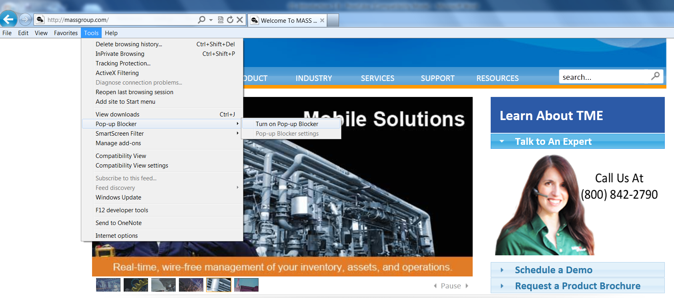
Figure 1 Example of Pop-Up Blocker Setting

Using the Yahoo toolbar:

- 1. Go to the Pop-Up Blocker icon in the Yahoo toolbar.
- 2. Click Disable Pop-Up Blocker

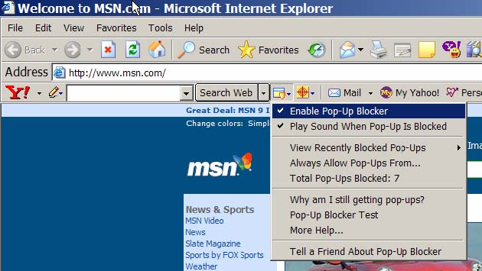
Figure 2 Alternate Example of Pop-Up Blocker Setting

Setting Security with the Pop-Up Blocker

Closing pop-up windows on the Internet may sometimes prove to be frustrating when the pop-up blocker is switched off. You may enable the pop-up blocker provided that you add the TME website as one of the trusted sites.

- 1. Open Internet Explorer
- 2. Click Tools
- 3. Click Internet Options
- 4. On the Privacy tab, check to make sure that the checkbox for blocking pop-ups is
- checked

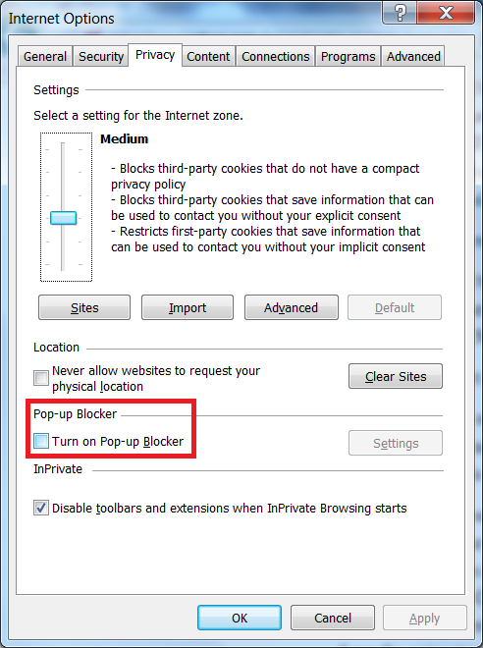
Figure 3 Internet Options - Privacy Screen

- 5. Click Settings
- 6. Type the URL (web address) in the ‘Address of Web site to allow’ box
- 7. Click Add
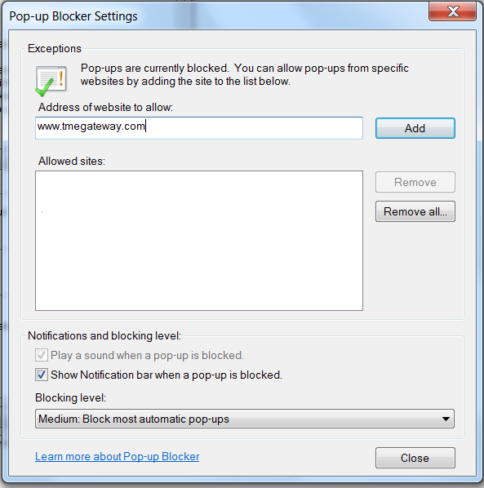
Figure 4 Pop-Up Blocker Settings Screen

- 8. Click Close.
- 9. Click OK in the Internet Options window.

In some cases, there might be two (2) or more pop-up blockers enabled. Some toolbars such as Yahoo may have their own settings. Look into the settings page for these toolbars and disable the pop-up blockers.

If using Internet Explorer 10 or higher, an additional step will need to be taken. Otherwise, a blank screen will appear in place of the log-in screen.

- Open Internet Explorer
- Click on Tools
- Click on Compatibility View Settings
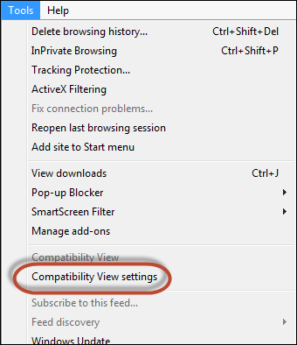
Figure 5 Compatibility View Settings for IE10 or Higher

- Select Display all websites in Compatibility View and click Close
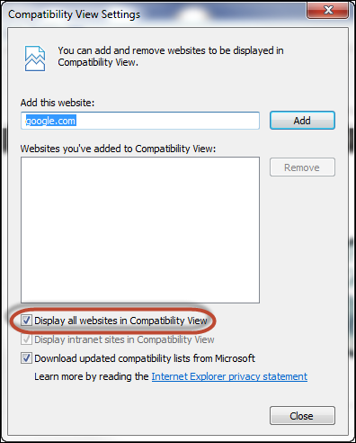
Figure 6 Selection for Compatibility View

Starting TME

- 1. Start Windows, if necessary.
- 2. Once Windows is running, you can start TME in one of three
- ways:
  - If you have a TME icon on your desktop, double-click on 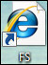

  - Open the Internet Browser. Enter the web address provided by your TME Administrator and press Enter.

  - If TME has been added to the list of Favorites, click Favorites and look for or something similar to this as your TME Administrator may have named it differently. Click this link and it will bring up the Login screen.

How to Login
In the Login page, simply enter your User ID and password, click
This will bring you to the default page which is the Dashboard Screen.

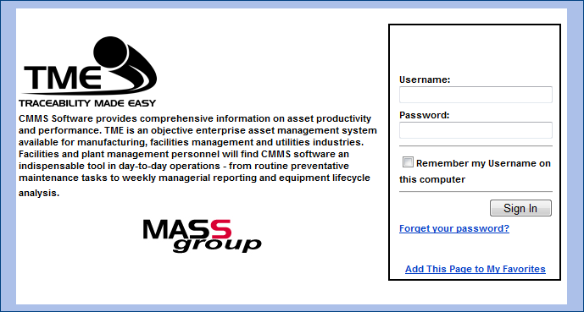
Figure 7 TME Log In Screen

I Forgot My Password
In the event that you forget your password, click on . In the pop-up window, enter your User ID and click Submit. Your password will then be emailed to you provided that your email address was entered into TME.

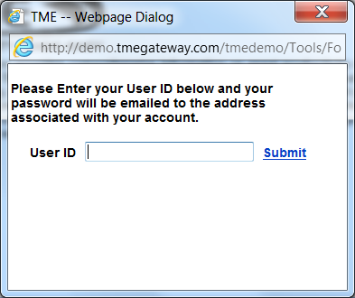
Figure 8 TME "I Forgot My Password" screen

Add This Page to My Favorites
If you wish to add TME to your Favorites, click on . In the pop-up screen, make sure to type the correct Name: and select the appropriate folder where you want to add TME as a bookmark. Click .

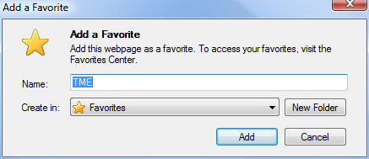
Figure 9 Internet Explorer Add a Favorite Screen

How to Logout
To logout out of TME, click on File on the Taskbar. Select . An alternative to logging out is closing the screen by clicking on at the top right corner of the main screen.

Once logged out, the session-end page will then be displayed indicating that the User has been logged out of the system.

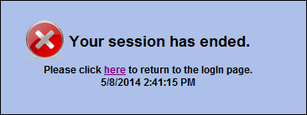
Figure 10 TME Session Has Ended Screen

Click on to return to the log-in screen.

Common Tasks

Common tasks are items that are utilized in the same manner throughout the application. The pathway to adding a Contact is the same as that of adding an Asset as it is for adding an Inventory Item. Tool/Taskbars are set up the same whether the User is in the Work Tracking module or Asset Management. The screens are set up in the same format utilizing Viewers and Detail screens.

Taskbar

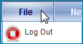
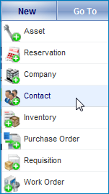
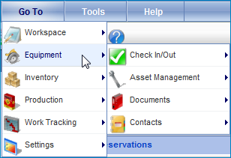
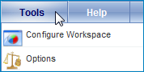
The Taskbar is available at the top of all screens within TME. With the Taskbar, you can log out of the application (see the Introduction and Overview Chapter for details), add a new item (i.e., add a new Asset even if currently in the Contacts module), follow a pathway to a screen using Go To, configure the Workspace and access the Help Feature.
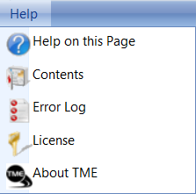

Figure 11 TME Taskbar
New

Various items such as Assets or Companies can be added from any screen within TME. Place the cursor over New and click on the Icon of the item to be added. This will bring up the appropriate blank Details screen. Enter the information and Save/Close using the Detail Toolbar. The Details screen will close and the item will be added; however, you are back to the original screen from which you were working. Go to the viewer in the appropriate Module to review the item.

Go To

Access any Menu Group, Module or SubModule with a single click. Place the cursor over GoTo and follow the pathway to the desired Menu Group, Module or SubModule icon/name and click on it. The screen will change accordingly and the destination name will be highlighted--whether it is the Menu Group itself or in the tree view within a Menu Group.
Tools – Configure Workspace

TME provides customization for the User to set up their own Menu Group tailored to what modules he/she uses most. To configure the Workspace, place the cursor over Tools and select Configure Workspace. A popup screen will appear. Select or deselect modules from the right pane. Modules selected will be highlighted in bold font in the left pane; modules not selected for your Workspace will be grayed out. To view the submodules associated with a module, click on the next to the module to maximize its portion of the tree. Click the next to the module to minimize. When finished making selections, click on OK. The popup screen will close. The Workspace menu group will now contain links for the selections just made.

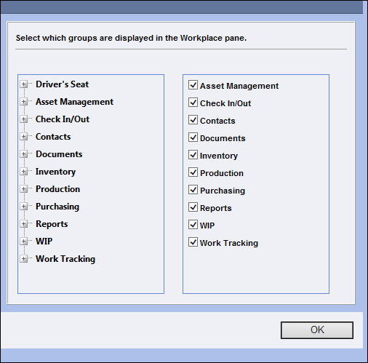
Figure 12 TME Configure Workspace Screen

Help Feature

The Help Feature can be accessed by placing the cursor over Help and selecting Help on This Page or Contents. By selecting Help on This Page, you are directed to the popup screen with the Help information pertaining to the screen from which you were working. By selecting Contents, you are directed to the popup screen with the Introduction and a tree view of the Help contents.

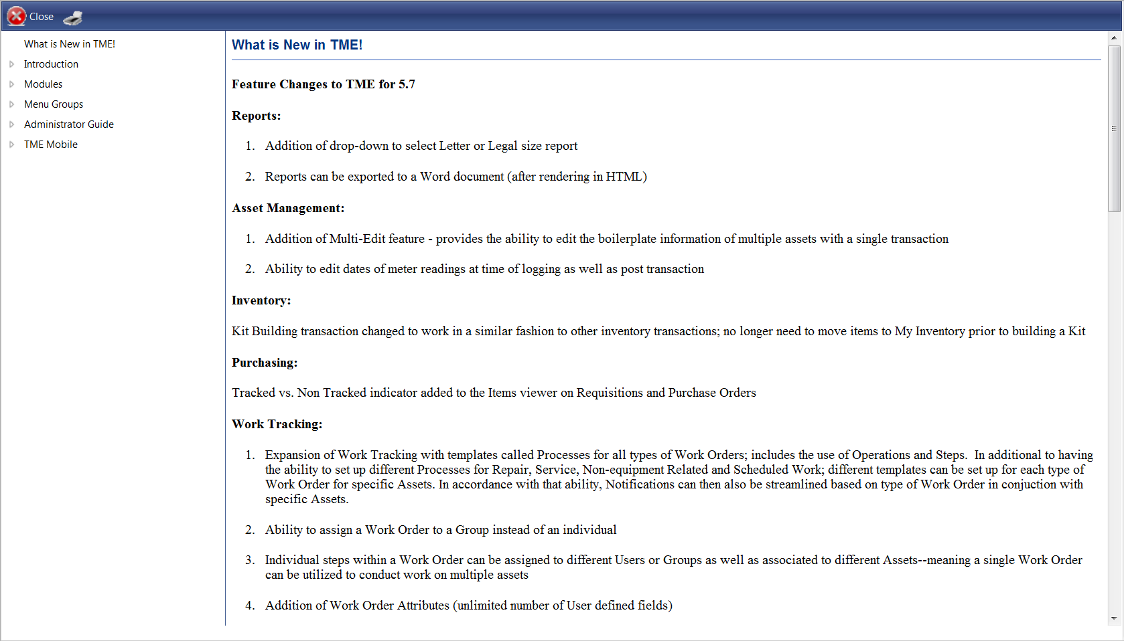
Figure 13 Default Page of Online Help Screen

Click on the arrows to the left of the topic needed and drill down to the subject title and click on it. The pane on the right will contain the information needed. If available, additional Related Topics can be accessed by clicking on the links at the bottom of the pane. The pane will refresh with the new topic contents.
To print the contents of the screen, click on the Printer icon . To exit the screen, click on the Close icon on the popup screen toolbar or close the window by clicking on the X at the top right corner of the popup. The User will be returned to the original screen from which he/she was working.
Main Screen Toolbar

The Main Toolbar is located on all screens just under the Taskbar. It contains icons for accessing the Help Feature as well as for adding new items such as Assets or Inventory Items from any screen within TME. To find out which icon is for which item, place the cursor over the icon and a tagline will appear with the description. Click on the icon to activate its function and the appropriate popup screen will appear.


Figure 14 Main Screen Toolbar

Viewer Toolbar
The Viewer Toolbar is located at the top of every viewer screen. It contains icons for adding a new item, exporting the viewer records to Excel, selecting saved searches, searching for specific records via a filter, and setting how many records are to be viewed per page. Some of the Viewers will have icons for Data Collection, multiple objects Update, selecting a Grid Control and setting up new Grid Controls (permission based, not all Users will have access).

Figure 15 Viewer Toolbar

Add New Item

Click on the icon for adding a new item (picture with "New" next to it) . This will bring up a blank Details screen. Enter the information accordingly and Save/Close using the Detail Toolbar. The Details screen will close and the item will be added and is now available in the viewer.

Export to Excel
The records from a Viewer can be exported to Microsoft® Excel with a single click. Click on the Excel icon . Depending on how the Internet is set up, you will most likely have a popup appear asking if you want to open or save the file. Select Open or Save (or Cancel). If Open is selected, Excel will open and the viewer records will be contained in a new file. If Save is selected, you will be asked to determine the path and name of the file and the file will be accessible at a later time. You are then returned to the Viewer screen.
If not all records within a Viewer are needed, the records can be filtered using the Search function or by the selection of a saved View. Once filtered, click on the Excel icon and the process is the same as if it were the full set of records.
Search Feature

A Viewer can be filtered to show a limited number of records. Click on the Toggle Search icon . The Search Filter will appear.
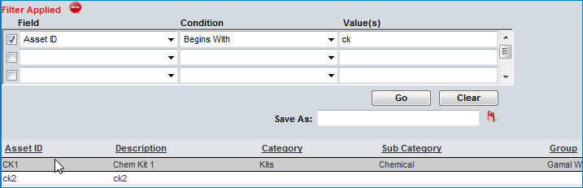
Figure 16 Viewer Search Control
Click on the first Field drop down menu and select a field (i.e., ID, Name, Category, Log Date, Description, etc). Next to the selected field, click on the Condition drop down menu and select a condition (i.e., Equals, Contains, Does Not Begin With, At or Before, etc.). Next to the selected condition, type in the Value for the selected field on which the Search is to be based. Occasionally, there might be a Calendar or Browse (...) icon within the Value field--click on the icon and select the Value to be used. Once all selections have been made, click Go. The Viewer will show only those records that meet the criteria.
The Search Filter can search up to five fields (using "and" not "or" statements--Category equals "ABC" and SubCategory contains "123", etc.) at a time. If necessary, use the scrollbar at the right side of the filter as only three rows are visible at any given time.
To deselect a criterion, click on the checkbox next to the criteria to be discounted. The selections for Field, Condition and Value will remain; but the Viewer will not include that criteria unless the checkbox is checked.
To clear out a Search and have the Viewer show all records, click Clear.
To close the Search Filter, click on the Search Toggle icon on the Viewer Toolbar. The Search Filter will close.

Views/Saved Searches

You can save a search. Set up a search and click Go. Verify that it is correctly set up, type in a name for the search in the Save As field, and click on the Save icon . The name of the search will now appear as a View in the Views drop down list.
Access the View at any time by clicking on the Views icon . A drop down list will appear with a list of the Views. Select the desired View. The Search Filter will populate with the appropriate fields, conditions and values and the Viewer will filter the records accordingly. Also, "Filter Applied To" will appear underneath the Viewer Toolbar along with the name of the View.
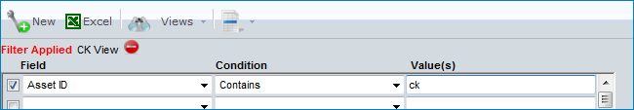
Figure 17 Search Control Set with View
To clear a View, click on the Toggle Search icon. The Search Filter will open. Click Clear and the fields will empty and the filter is cleared. The Viewer will be immediately restored with the full set of records. Make new selections for an alternate search or click on the Toggle Search icon to close the Search Filter.
To delete a View, select the View from the drop down list to apply it to the Search Filter and click on the Delete icon . Click to clear out the Search and the Viewer will be immediately restored with the full set of records.

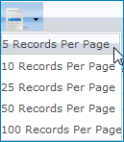
Setting Records per Page
Figure 18 Records per Page Drop Down
The number of records shown per page is changed by clicking on the Records per Page icon. A drop down list appears. Select either 5, 10, 25, 50 or 100 Records Per Page and the Viewer will refresh accordingly. The links for the page numbers are at the bottom right side of the Viewer. If there are more records on the page than will fit on the screen, a scrollbar will appear on the right side of the Viewer.

Update: Multi-Edit Function
Certain records/objects can be mass edited. Select the objects via the checkboxes in the Select column. Click on the Update button on the Viewer Toolbar.
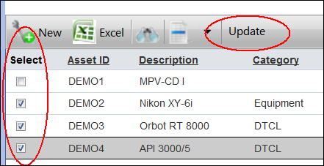
Figure 19 Asset Multi-Edit Feature

The Properties screen will appear with the selected objects on the left. Click on the checkboxes for the fields to be edited. Enter the value for the fields accordingly and click OK. If the checkbox for the field is not selected, TME will not know to edit that field. This is in place to prevent blanks getting inserted for fields that are not to be edited.
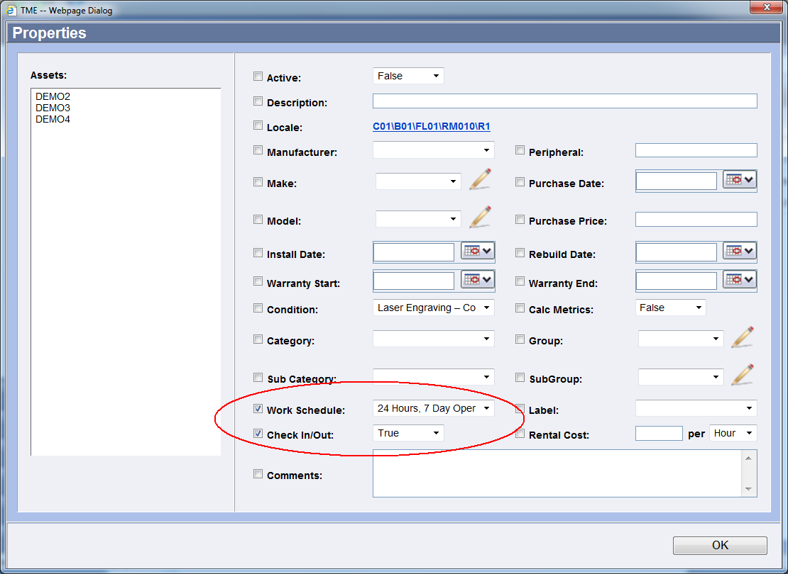
Figure 20 Multi-Edit Properties Screen

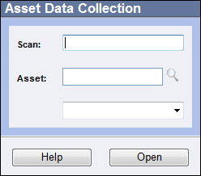
Data Collection
The Data Collection feature provides the ability to conduct multi-instance data collection for various objects throughout TME. Variable Groups can be selected to form Data Collections. These can then in turn be associated with Assets, Inventory Items, Batch Numbers, Serial Numbers, Work Orders, and Steps. Users can use the Data Collections to collect meter readings (totalizer variable), upload calibration certificates (document variable) directly (to a work order, asset or even inventory item), etc. Whereas Attributes are single instance collections of data in that data is entered and stored once, data collections are a continuous collection of information. The data is stored for each item and can be edited (TME does maintain an audit trail) from the items detail screen.
Figure 21 Collection Screen for an Asset
To collect data on an object, click on the Data Collection icon from the Object Viewer taskbar (then scan the appropriate barcodes or select using the object LookUp screens) or from the object detail screen toolbar (object will already be populated; select the Data Collection from the drop-down list and click on the Open button).
The Collection screen will open.
If the variable is required, it may have a default entry already applied. If the default entry applies, then the User does not need to make any changes. If the default entry is incorrect for the object, then the User will need to change the value accordingly.
- Text, Date, Number, List, and Checkbox Variables
To enter a value into a Text variable, click in the field and type the entry. For a variable that requires a Date, click on the Open the Calendar Popup icon and select the date. Some variables require the entry of a Number, click in the field and type in the number. For those variables with a drop-down List, click on the arrow on the right side of the drop-down field and select the appropriate entry. If a variable has a Checkbox, click the checkbox if the value is to be applied to the object.
- Document Variable
To upload a file or enter in a URL address for a Document variable, click on the Attach Doc icon to the right of the field. The Document Selector screen will appear. If uploading a file, click on the Select button and browse to the file. If no Select button is available, type in the full URL address for the document. Click Save when finished. The Document name will appear in place of "No Document Selected" or the name of the previously uploaded file.
- Formula Variable
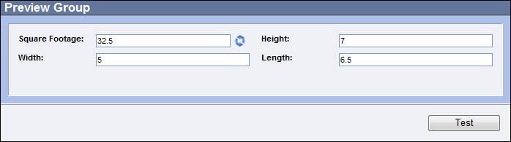
To view the calculation for a Formula prior to saving the record, make sure all number variables have been populated and click on the Calculate icon to the right of the formula field. If the calculation cannot complete due to the number variables not being filled in (or the numbers and/or calculation are not within preset limits), there will be "--Error--" inserted into the field. Otherwise, the formula will calculate and populate the result.
Figure 22 Example of Numbers and Formula Variable Group

- Totalizer Variable
The Totalizer variable replaces the meter feature from previous versions of TME. This variable works in exactly the same way as the meters. The data is collected in a different way. To enter a value, type it in to the totalizer field. If the value does not fall within the preset limits, a popup message will appear upon submission of the data collection. Change the value or cancel the data collection by closing the screen. To view previous readings, click on the icon to the right of the field. NOTE: if the totalizer is associated with more than one object, the readings will be collated and be applicable to all of the objects associated with the totalizer.
- SPC and SPC Formula Variables
The SPC variable is used in lieu of the SPC module of TME versions prior to 5.8. Enter the values of the points in the fields provided. To view the chart of previous entries, click on the icon to the right of the first point field. The X-Bar and R charts will appear.

The SPC Formula Variable works similarly to a regular Formula variable in that it automatically calculates a value based on the entries made to configured Number variables on the screen. The difference is that the calculated value is defined as an SPC value that is charted and has a target as well as specification and control limits.

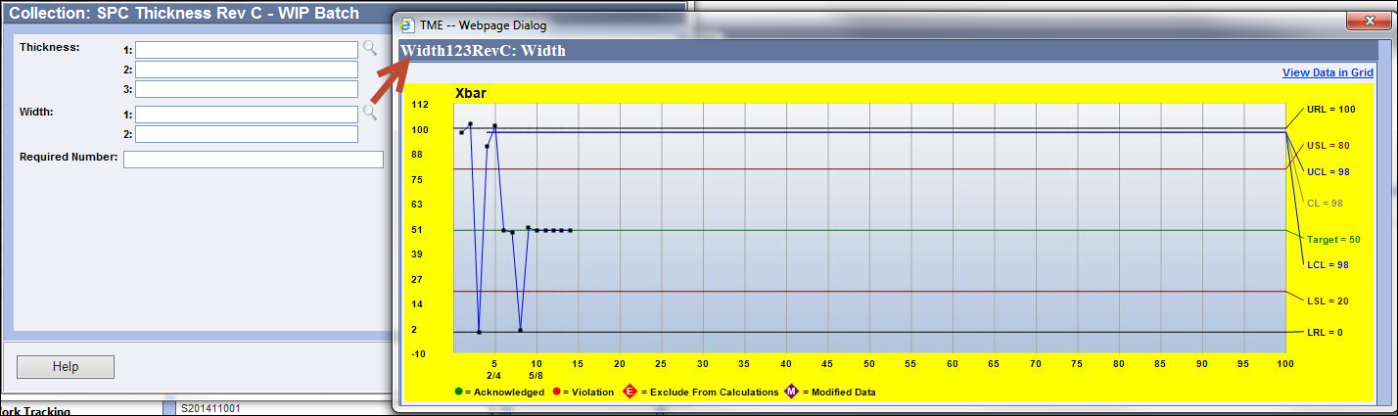
Figure 23 SPC Data Collection Screen and Xbar Chart

- View Data in Grid
The View Data in Grid link at the top right of the chart screen will show the data in a grid format.

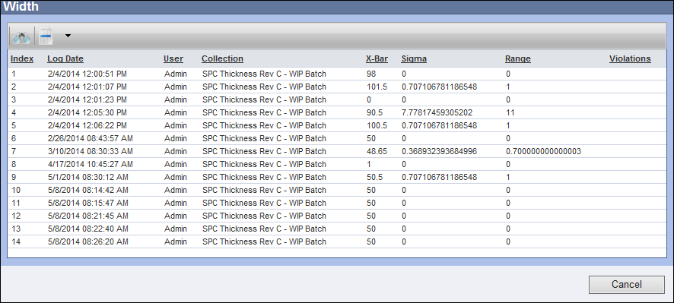
Figure 24 Data Viewed in Grid
- Point Detail Screen
Click on a data point within either chart to display the Point detail screen for that point. The screen shows the Sub Group designation, control limits, X-bar, Range, Cp, Cpk, values reported and the violation(s) of any run rules.

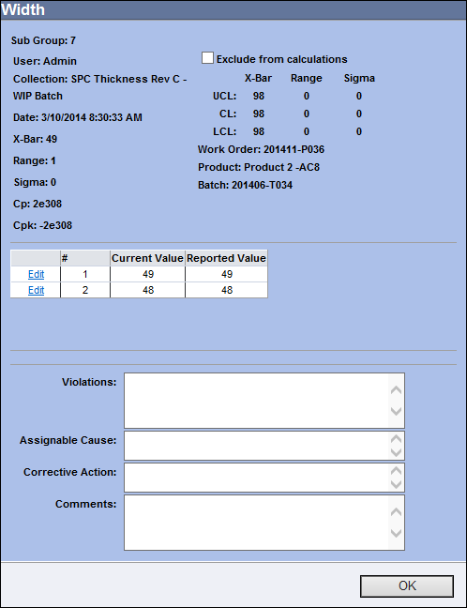
The data point can be excluded from calculations by selecting the checkbox "Exclude from Calculations." The Exclude from Calculations tag will display in the charts above the data point to indicate its exclusion.
Figure 25 Point Detail Screen
If a violation has been indicated, the Assignable Cause, Corrective Action and Comments may be typed in accordingly.
To edit the data point. click the Edit link to the left of the value number that needs to be changed. Type in the new values and click Update to save the change or Cancel to cancel. The Modified Data tag will display in the charts above the data point to indicate its modification.
Click the OK button to close the screen.

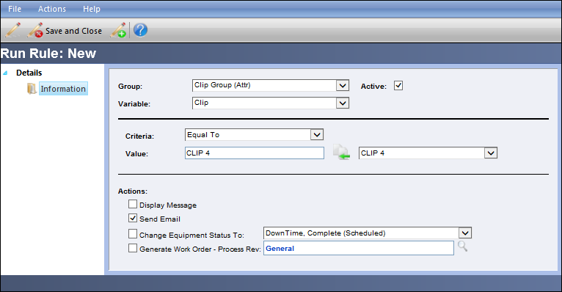
Click Submit when all of the data has been entered. Entered data can be reviewed, and if applicable, modified on the Data Collection screen for the object (accessed via the Data Collection link on the object’s Detail Screen).

- Run Rules
Run Rules may be set up by the TME Administrator to provide consequences should an entry be made that does not follow the “rules” for the given object. Consequences may include the displaying a message, sending an email, changing the equipment status (when associated with an Asset), or generating a work order (when associated with an Asset). These consequences can be set off when the entry does not equal, contain, does equal, is less than, etc., a given set of values. For an SPC variable, the run rules are based on violations to Western Electric rules (definitions for these rules are provided onscreen when set up).
Figure 26 Example of Run Rules Setup (See Chapter 10 Settings for More Detail)

For how to set up data collections and link to objects, see Chapter 10 Settings.

Grid Control Selection and Configuration
The Grid Control feature provides the ability to choose the columns displayed on the viewer.

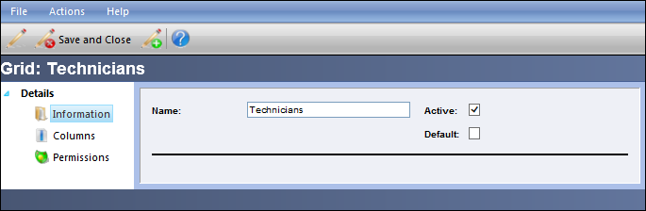
- Grid Control Configuration
Click on the Configure Grid icon . The Grid Views screen will appear. Click on the icon for adding a new Grid . This will bring up a blank Details screen. Enter the the name of the new Grid Control, select the Active checkbox to make it available to
Figure 27 Grid Control Detail Screen
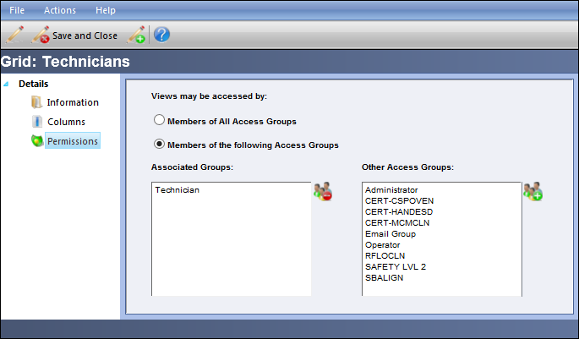
TME Users. Only select the Default checkbox if the new Grid is to serve as the Default grid for new users. Click Save to activate the Columns and Permissions links.

Click on Permission if the Grid Control is to be accessed only by members of specifc Access Groups. To allow any TME User permission to access the Grid, select the Everyone checkbox. To restrict permission, select the checkbox for "Members of the following." Select the Access Groups and/or Users.
Figure 28 Permissions Link for Grid

Click on the Columns link to select the fields to be viewed as columns and/or to be set up as Search fields.
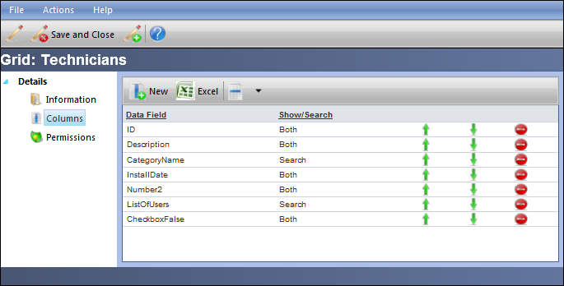
Figure 29 Columns Link for Grid
Click on and select the column type. If the field is a standard TME field, choose “Table”. If it is a user-defined Attribute set up by the TME Administrator, choose “Attribute.” Select the Column desired and choose the option of “Show” if field is only to be shown as a column onscreen, “Search” if it is only be used for conducting a Search on the viewer, or “Both” if it is to be both a column and a searchable field. Add more fields by clicking on Save/New . Click Save/Close when finished. The Details screen will close and the Grid will is now available on the Grid Control Selection screen. Close the Grid View screen.
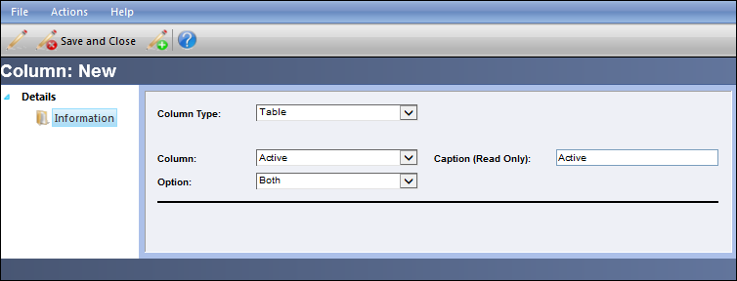
Figure 30 Column Selection for Grid

- Grid Control Selection
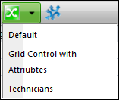
To select which Grid to view, click on the Grids icon and a drop down listing of the available grids will appear.

Select the Grid and the viewer and available Search fields will adjust accordingly. The Grid chosen will remain in place as the User maneuvers through and logs in and out of TME until he/she chooses an alternate Grid.

Details Screen Toolbar/Taskbar
Figure 31 Grid Selection
The Details Screen Toolbar and Taskbar are located at the top of all Detail Screens. They contain icons for accessing the Help Feature and Saving an item (new and/or edited). To find out which icon is for which item, place the cursor over the icon and a tagline will appear with the description. Click on the icon to activate its function.
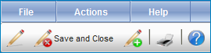
Figure 32 Details Screen Toolbar/Taskbar

Saving a Record
The Save icons are located in the Details Screen Toolbar or accessed by clicking on File on the Details Screen Taskbar. To save an item and leave the screen open, click on the Save icon . The record can be further edited and saved again (or closed without saving). To save an item and close the screen, click on the Save/Close icon . After the Details Screen closes, you are returned to the Viewer screen. To save an item, close the screen and open a screen to add a new item, click on the Save and New icon . The original Details Screen closes and a blank Details Screen appears.
Closing a Record
If a record does not need to be saved (it was only viewed and you decide not to keep the edits entered), the Details Screen can be closed without saving by clicking File on the Details Screen Taskbar and then Close. An alternate method is to click on at the very top right corner of the Details Screen window. You are then returned to the Viewer screen.
Properties Information of a Record
The properties information of a record includes the fields Created By, Created On (Server date and time), Created On (UTC date and time), Updated By, Updated On (Server date and time), and Updated On (UTC date and time). Access it by clicking File on the Details Screen Taskbar and then Properties. A popup screen appears with the information. Click on or the at the very top right corner of the popup window to close the screen.
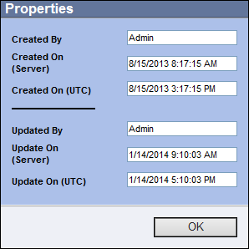
Figure 33 Properties Screen of a Record

Deleting a Record
To delete an item within a Viewer, double click on the item row or right click and select View. Click on Actions on the Details Screen Taskbar and then Delete [Item]. A popup screen with the message "Are you sure you want to delete" will appear. To cancel the deletion, click on Cancel or on at the very top right corner of the popup window to close the screen. Click to continue. You will be returned to the Viewer and if deleted, the record will no longer appear in the viewer.
An alternate method for deleting a record is to right click on the row of the record within the Viewer and select Delete.
Printing a Record
Throughout the application, print items such as forms and labels are available for printing and scanning. Labels may include just a barcode and an item name or additional information such as serial numbers, locales, etc. Forms may include signature lines, headers, graphics, etc. The Print submodule (See the Settings Chapter) allows for the creation of different types of labels and forms for Assets, Inventory Items, Users, Requisitions, Purchase Orders, Work Orders and Locales by the TME Administrator.
To print a label or form, select a record within the item's Viewer and double click anywhere within the row or right click within the row and select "View." The item's Details screen appears set to the Information Link. Click on "Print Label" via Actions on the Taskbar or click on the Printer icon on the Toolbar (in the case of a Work Order or on a Receipt, click on the "Print [Item]" link located on the screen itself, Check In/Out receipts print automatically upon completing the transaction). The label or form will open up as a pdf file. Use the pdf toolbar to print or save the document. To request a different type of form or label, contact the company TME Administrator.
Help Feature via the Details Screen
The Help Feature can be accessed via the Details Screen by placing the cursor over the Details Screen Taskbar and selecting Help on This Page or Contents. To access Help on This Page from the Details Screen Toolbar, click on the Help icon .

Selecting a Locale
To set the locale for an item, click on the Locale link and the Select Locale popup will appear.

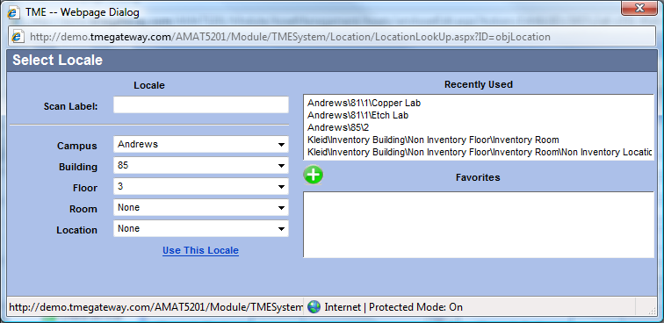
Figure 34 Select Locale Screen

To scan a label, click within the Scan Label field and scan. The series of Locale drop-downs will populate accordingly. If not using a scanner, select the Campus from its drop-down list, the Building from its drop-down list and continue until the full string is complete. You may also click on a Locale string in the Recently Used or Favorites field. Click on to save the locale. To place a locale string into the list of Favorites, click on . Up to five favorites may be saved at any given time.

Item LookUp Screens

Throughout TME, there are fields whereby an Item LookUp screen is utilized to select an item. The field will have the icon to the right of it.

Figure 35 Field Set to LookUp Screen

When the icon is clicked, the appropriate Item LookUp screen will appear and contains the list of items for which permission to access has been provided.

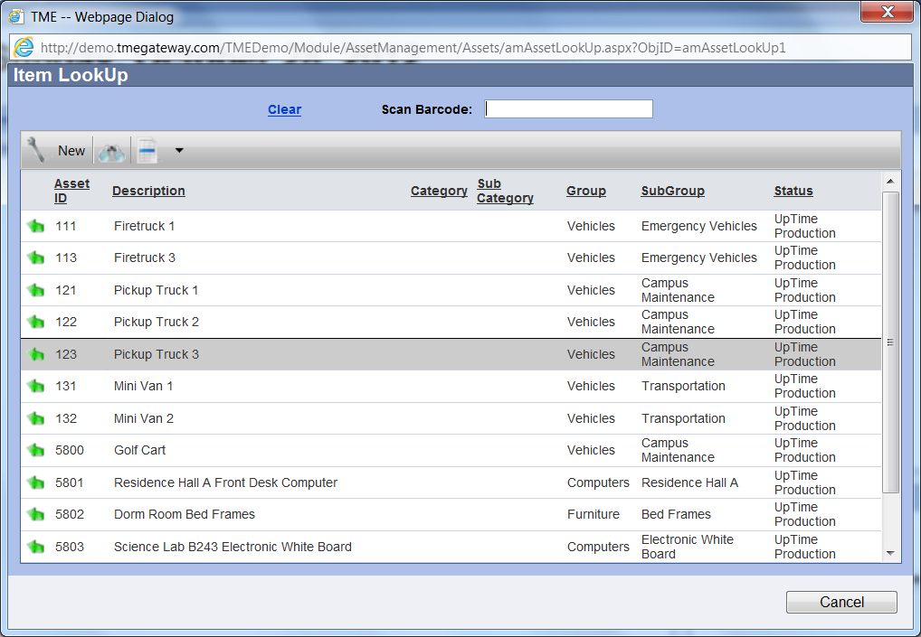
Figure 36 Item LookUp Screen

The Search, Views, Records per Page and Add New (if permission has been provided) functions are available at the top of the screen. Select the item by clicking within the Scan Barcode field and scan the item’s barcode or by clicking on the Select Item icon to the left of the item (click the Cancel button at the bottom of the screen or the Clear link at the top to cancel). The screen will disappear and the selected item is now entered into the field as a link to its own detail screen.

User Settings
The User Settings screen includes the fields/links for Username, Resetting Password, and Restore Default Settings. The Username field shows the name of the User who is logged in. The Resetting Password link allows the User to reset his/her own password. A User can set all of the Search, Views, Sort and Records Per Page Settings back to the default settings by clicking on the Restore Default Settings Link.
To access the User Settings, click on the User: [Username] link to the right and above the Viewer. A popup screen with User Settings will appear. Make selections (if needed) and click on . To close the window without saving new selections, click on at the very top right corner of the popup window to close the screen.

Sorting by Column within a Viewer
The underlined column headers can be used to sort the order of the records listed in any Viewer. Click once on a column header and the order will be reset in either ASCENDING to DESCENDING or vice-versa. Click again to reset in the reverse.

Editing Drop-Down Lists
If a drop-down list does not contain a needed entry and there is a icon, click on it change it from a drop-down list to a text field. Type in the new entry. Once the screen has been saved, the field will become a drop-down list again and the entry will become a value of the drop-down list for future records.

If the icon is not available, then the drop-down is populated by a drop-down management tool that is managed by the TME Administrator.

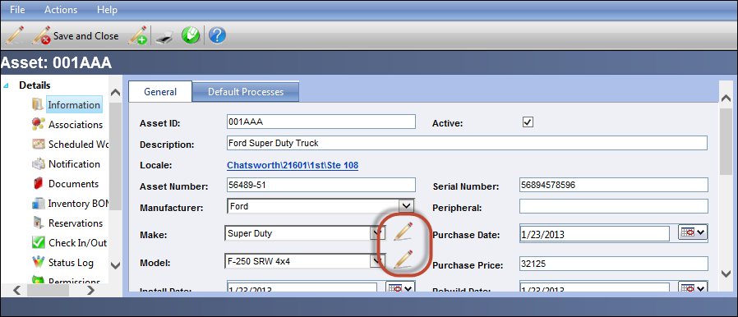
Figure 37 Drop-Down List Editing Icons

